Stop Switch

Vault Folder: STOPSWITCH

Nathan Clack

Research Specialist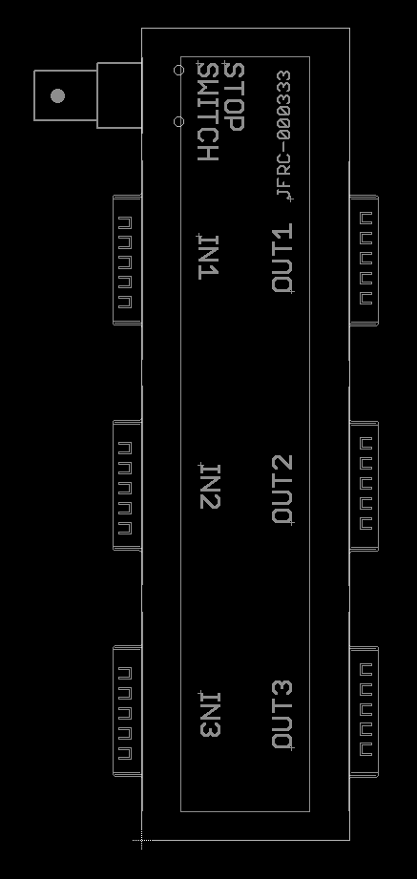

Steve Sawtelle  
Electrical Engineer, ID&F  
(571) 209-4158

Contents

System Overview 2

Hardware Development 2

Assembly, Test, and Calibration 5

# System Overview

The Stop Switch provides an emergency stop for stage drivers on a microscope. It consists of two parts: the stop switch in an enclosure and the interface electronics. The two are connected via a standard BNC cable.

# Hardware Development

The interface electronics is designed to be installed in-line with the existing cables so that no modifications are required.

The stop switch interface consists of OR’ing the stop line from each axis of the stage with the stop switch signal. The stop switch is a normally closed momentary switch. This ensures that any interruption, even a cut or missing cable will cause a STOP condition. Although any switch of this type can be used, a large prominent switch creates the best user interface.

*Schematic*

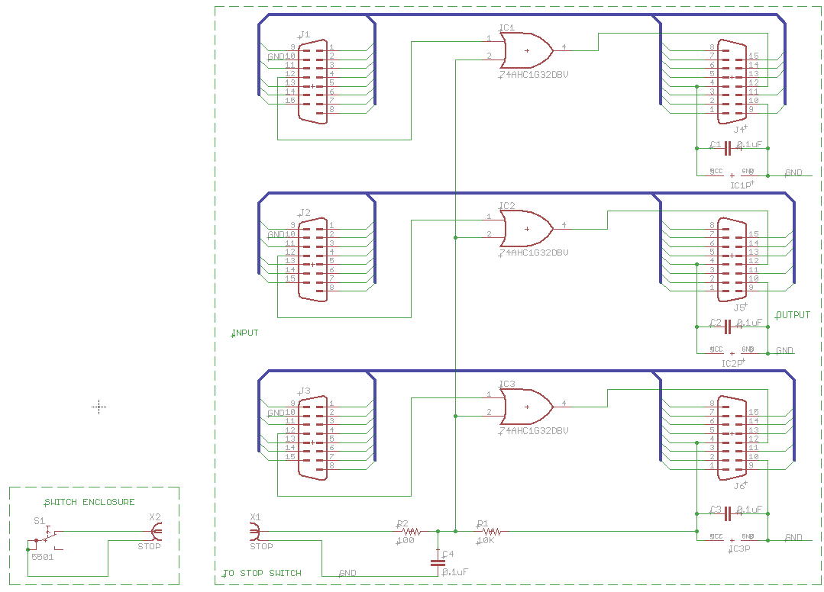*Printed Circuit Board*

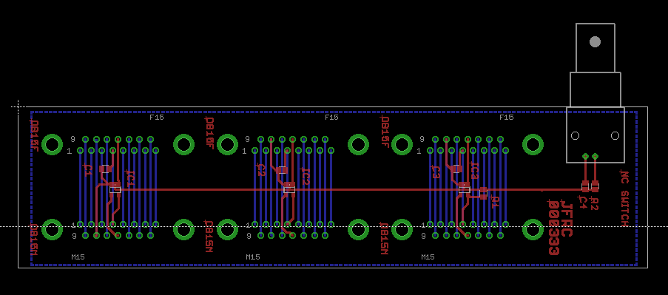

*Materials*

|  |  |  |  |  |  |  |
| --- | --- | --- | --- | --- | --- | --- |
| Partlist exported from C:/_Workspace/DATA/PROJECTS/STOPSWITCH/ECAD/StopSw_000333.sch at 8/29/2013 1:47:22 PM | | | | | |  |
|  |  |  |  | Digi-Key | Manufacturer | Manufacturer PN |
| Qty | Value | Device | Designators |  |  |  |
| 3 |  | DB15 | J1 J2 J3 | A105027-ND | TE Connectivity | 3-106506-2 |
| 3 |  | DB15DB15M | J4 J5 J6 | 5747841-6 | TE Connectivity | 5747841-6 |
| 4 | 0.1uF | CAPS0805S | C1 C2 C3 C4 | 478-3755-1-ND | AVX | 08053C104KAT2A |
| 1 | 10K | RESISTOR_SM0805S | R1 | 541-10.0KCCT-ND | Vishay | CRCW080510K0FKEA |
| 3 | 74AHC1G32DBV | 74AHC1G32DBV | IC1 IC2 IC3 | 296-1093-1-ND | TI | SN74AHC1G32DBVR |
| 1 | 100 ohms | RESISTOR_SM0805S | R2 | 541-100CCT-ND | Vishay | CRCW0805100RFKEA |
| 1 | BNC | 227161-9 | X1 | A32261-ND | TE Connectivity | 5227161-9 |
| 1 |  | Enclosure (cut down) |  | HM892-ND | Hammond | 1455J1601 |

|  |  |  |  |  |  |  |
| --- | --- | --- | --- | --- | --- | --- |
| STOP SWITCH - switch assembly | | |  |  |  |  |
| Quantity | Description | Manufacturer | PN | Source | Source PN | Notes |
| 1 | Enclosure | Hammond | 1590AFLBK | Mouser | 546-1590AFLBK | Machine per picture |
| 1 | Switch |  |  | McMaster | 5374T37 |  |
| 1 | BNC | Amphenol | 112624 | Mouser | 523-112624 |  |

# Assembly, Test, and Calibration

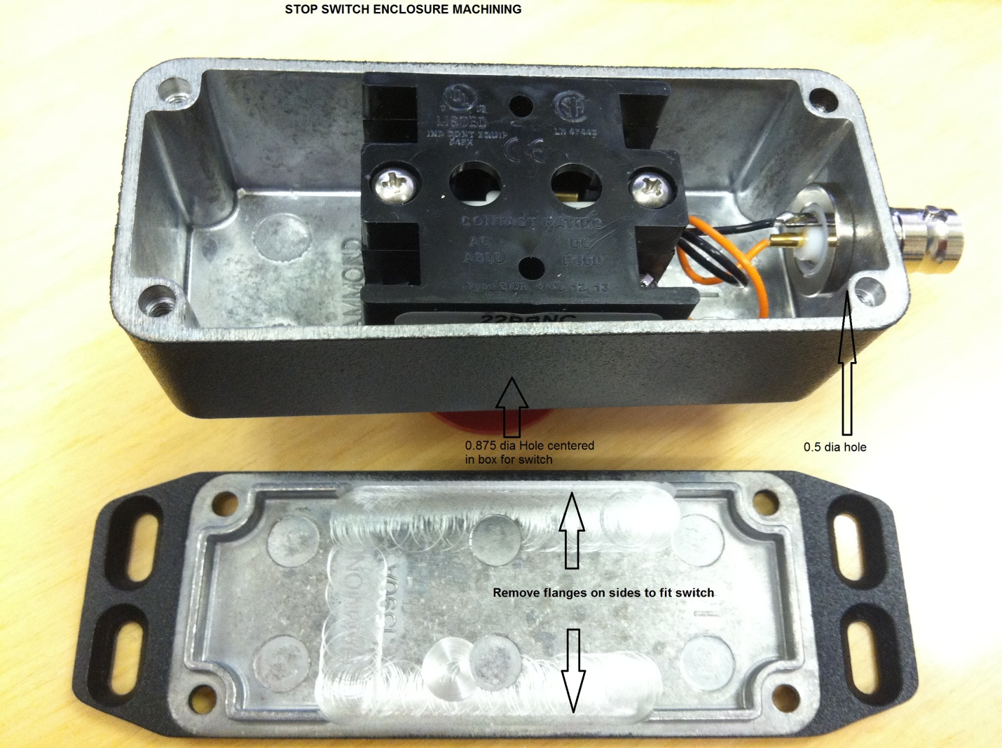

Wire the NC contact and common to the BNC connector.